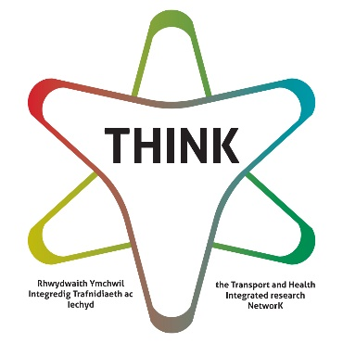
Just Transition or Just a Transition Workshop FAQs

Will there be breaks?
Yes, the workshop will be for 90 mins and there will be a break after 60 mins. Whilst the workshop will be interactive, you are welcome to turn your screen off and look away from the screen or get up and move around if you need to during the course of the workshop.

Will the materials be available ahead of time so that I can prepare?
Yes, we will circulate the materials to all those who have signed up in advance of the workshop. If you have not received anything in the email you signed up with (it may have gone to your junk mail, so do check there first) before the 28th Feb, please email think@aber.ac.uk

What online platform will you be using?
Zoom - this platform's accessibilty features can be explored before the workshop via this link https://www.zoom.com/en/accessibility/ but if you want to test anything out with us before the event, please email think@aber.ac.uk

Will I have to write things on an online whiteboard to take part?
No, we will have designated people to write things on a shared online document (using Miro and Google Docs) so that everyone's contributions are captured and seen by those in the workshop. Therefore, all those taking part can just concentrate on coming up with great ideas!

Will you be using break out rooms?
Yes, we will put you into break out rooms and change those rooms around so that you get to meet different people in the workshop. We will also have a 'quiet space' break out room so you can remain in the main space if you need to take a break.

Can you provide British Sign Language interpreters?
Yes, please email think@aber.ac.uk if this is something that you think will help you get the best from the workshop.

How do I contact the organiser if I have further questions?
You can email Amy Nicholass, Project Officer for THINK and workshop coordinator at think@aber.ac.uk and you can call Amy within normal GMT working hours on Mondays, Wednesdays and Thursdays at +44 (0) 197062 8438.

Do I have to have my camera on?
No, camera off is fine if that is your preference or you have band width issues, however others who require camera on to enable them to lip reader might benefit from cameras on when you are speaking if that is possible and you are comfortable with that, otherwise, use the chat function to contribute.

Can I take part if I don't want to speak out loud to the whole group?
Absolutely. Whilst Andy will be leading the workshop, Amy will be checking regularly on the chat function of Zoom to check for any questions, comments and emojis.

